**CVMC Professional Nursing Practice Model**

**Revised: May 10, 2018; 2011**

**Original Date: 2008**

**CVMC Professional Nursing Practice Model**

##### Introduction

Catawba Valley Medical Center’s (CVMC) Professional Nursing Practice Model is a framework for all professional registered nurses (RN’s) employed by Catawba Valley Medical Center. The Professional Nursing Practice Model is created to facilitate excellence in outcomes by providing the essential elements that guide decisions and to ensure consistency of nursing practice throughout CVMC’s practice settings.

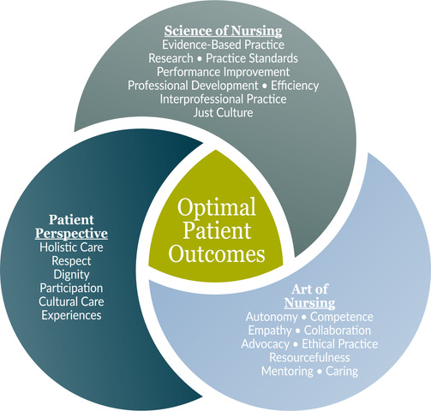

Professional Nursing Practice Model

CVMC’s Professional Nursing Practice Model is rooted in evidence-based practice. Using the best available research evidence to guide decisions, nurses incorporate professional expertise and judgment. The nurse and the patient discuss effective interventions and ascertain that care is consistent with the patient’s values and preferences.

The organizational system and environment in which nursing practice occurs is as important as the practice itself. Therefore, the Professional Nursing Practice Model is the foundation utilized in nursing policies and procedures, recruitment and employment practices, nursing orientation, job description creation, competency development, the professional enrichment program, shared governance, and performance and peer review development. Accountability for care is shared between nursing management and clinical nursing care in the following ways.

### Nursing management is accountable for the “Context;”

* Human Resources,
* Fiscal Resources,
* Material Resources,
* Support Resources,
* System Requirements.

Clinical nursing staff is accountable for the “Content;”

* Defining practice,
* Defining the outcomes,
* Defining competence. *Tim Porter O’Grady (personal communication, Jan. 26, 2006)*

**CVMC Nursing Mission**

CVMC nurses will support the overall mission of Catawba Valley Medical Center through the science and art of professional nursing practice while also engaging the patient’s/person’s perspective.

## CVMC Nursing Vision

CVMC nurses will be a role model for the achievement of excellence in professional nursing practice.

##### Nursing Professional Practice

Nursing is a professional practice discipline existing to provide care to patients, their families and/or communities served. The goal of nursing is to assist patients in attaining their maximum level of wellness. When that can no longer be attained, the goal then becomes supporting a death with dignity and compassion. Registered nurses diagnose and treat human response to actual or potential health problems through the nursing process. Nursing interventions are intended to produce beneficial effects and contribute to quality outcomes. Professional nursing practice is defined by, but not limited to, the NC Nurse Practice Act, ANA Code of Professional Practice, Nursing’s Social Policy Statement, ANA Nursing Scope and Standards of Practice, ANA Scope and Standards for Nurse Administrators, as well as various other organizations’ practice standards. Each nurse remains accountable for the quality of care within his or her scope of nursing practice. The nurse’s engagement in professional practice is dependent upon their educational preparation, their experience, their role, and the nature of the patient population they serve. “Development of any clinical discipline is dependent on the willingness of leaders to serve, facilitate, and mentor.”[[1]](#endnote-1)

# cid:D33816C8-B9B2-44E6-B021-7125BC240A68The Model

The Model for Professional Nursing Practice at CVMC is synergistic in nature. Excellence in practice is built by incorporating all three elements of the model. In the nursing profession, the term “patient” is defined broadly to encompass the individual person, families, communities or groups. This model was developed for all aspects of professional nursing practice including, but not limited to, direct care nursing, patient care managers, educators and nurse leaders.

* The first element of the model is the science of nursing. Key concepts in this level are research, evidence-based practice, and practice standards.
* The next element of the model represents the art of nursing. Resourcefulness, autonomy, empathy and collaboration contribute to the ability of the nurse to practice in an ethical, caring and competent manner.
* The last element of the model emphasizes the importance of the patient’s preferences, values, and beliefs relative to the professional nurse’s practice. The patient’s input is integral to the decision-making process that drives his/her healthcare plan.

Integration of these concepts promotes quality nursing practice at every level of decision making and leads to optimal patient outcomes which is the center of the model.

# C:\Users\aandreu\AppData\Local\Microsoft\Windows\Temporary Internet Files\Content.Outlook\CAZ5FOFM\Puzzle_11217_S (002).jpgThe Science of Nursing EBP Practice Model

**Evidenced-Based Nursing Practice** integrates the best available scientific evidence, nursing clinical expertise, and patient preferences and values into the decision-making process for patient care.

**Research** is a “systematic investigation, including research development, testing and evaluation, designed to develop or contribute to generalizable knowledge.”[[2]](#endnote-2)

Figure 2

**Performance Improvement** represents identifying and acting upon opportunities for improvement utilizing established metrics to measure progress towards established goals.

**Practice Standards** are authoritative statements by which the nursing profession describes the responsibilities for which its practitioners are accountable. Written in measurable terms, standards also define the nursing profession’s accountability to the public and the outcomes for which registered nurses are responsible.[[3]](#endnote-3)

**Professional Development** moves a competent nurse beyond entry level education towards excellence in practice. Methods of acquiring professional development include formal education, continuing education, certification, review of professional journal articles, scholarly research, and participation in professional conferences.[[4]](#endnote-4) “Nurses have a responsibility to pursue life-long learning improving both knowledge and skills to advance the individual nurse’s practice.”[[5]](#endnote-5)

**Interprofessional Practice** is terminology used to refer to professions working together with a common purpose, commitment, and mutual respect.

**Efficiency** is a measurable concept that refers to the process of achieving a desired outcome, with very little waste of effort, energy, or material goods.

**Just Culture** is a framework that assists an organization in creating a culture of safety, maintaining reliability, and establishing a fair system of justice.

# cid:D33816C8-B9B2-44E6-B021-7125BC240A68The Art of Nursing

Accountable and autonomous nursing practice requires knowledge, skill, competence, and experience. It is expected that CVMC nurses be ethical, caring, sensitive, and maintain positive attitudes. Professional development is a cornerstone for advancing these core values.

**Autonomy** is the freedom to act on what you know it is in the best interests of the patient, to make independent clinical decisions in the nursing sphere of practice and interdependent decisions in those spheres where nursing overlaps with other disciplines.[[6]](#endnote-6)

**Competence** is the ability to integrate knowledge; skills; experience; and critical thinking to perform a specific skill or to fulfill the role of a professional nurse.

**Collaboration** is a positive working relationship based on the belief that all members of the healthcare team make essential contributions toward optimal patient outcomes.

**Advocacy** is the protection and support of the patient’s rights, safety and health.

**Resourceful** nurses can act effectively, skillfully, and imaginatively, especially in challenging situations.

**Empathy** is the state of being aware of, being sensitive to, and vicariously experiencing the feelings, thoughts and experiences of another.[[7]](#endnote-7)

**Mentoring** is a collegial relationship that is undertaken for the purpose of counseling, guiding, advising, encouraging and inspiring.

**Ethical Practice** is based on the *Code of Ethics for Nurses, American Nurses Association, 2015[[8]](#endnote-8).* Ethics is an integral part of the practice of nursing. Nursing encompasses the prevention of illness, the alleviation of suffering, and the protection, promotion, and restoration of health in the care of individuals, families, groups and communities. Individuals who become nurses are expected not only to adhere to the ideals and moral norms of the profession but also to embrace

them as part of what it means to be a nurse. The ethical tradition of nursing is self-reflective, enduring, and distinctive. A code of ethics makes explicit the primary goals, values, and obligations of the profession.

1. The nurse practices with compassion and respect for the inherent dignity, worth and unique attributes of every person.
2. The nurse’s primary commitment is to the patient, whether an individual, family, group, community or population.
3. The nurse promotes, advocates for, and protects the rights, health and safety of the patient.
4. The nurse has authority, accountability, and responsibility for nursing practice, makes decisions, and takes action consistent with the obligation to promote health and to provide optimal care.
5. The nurse owes the same duties to self as to others, including the responsibility to promote health and safety, preserve wholeness of character and integrity, maintain competence, and continue personal and professional growth.
6. The nurse, through individual and collective effort, establishes maintains and improves the ethical environment of the work setting and conditions of employment that are conducive to safe, quality health care.
7. The nurse, in all roles and settings, advances the profession through research and scholarly inquiry, professional standards development, and the generation of both nursing and health policy.
8. The nurse collaborates with other health professionals and the public to protect human rights, promote health diplomacy, and reduce health disparities.
9. The profession of nursing, collectively through its professional organizations, must articulate nursing values, maintain the integrity of the profession, and integrate principles of social justice into nursing and health policy.

**Caring** is defined by Kristen M. Swanson, RN, PhD, FAAN in Five Caring Processes.[[9]](#endnote-9)

1. ***Maintaining Belief*** – Maintain a fundamental belief in persons and their capacity to make it through events and transitions and face a future with meaning. Practices include having faith, maintaining a hope-filled attitude, going the “extra mile.”
2. ***Knowing*** – Strive to understand an event as it has meaning in the life of the other – understand the lived realities of those served. Practices include avoiding assumptions, centering on the other, thoroughly assessing, seeking cues and expertise from other colleagues.
3. ***Being With*** – Be emotionally present to the other. Practices include being there, enduring, listening, attending, disclosing not burdening.
4. ***Doing For*** - Do for the other what they would do for themselves if it were possible. Practices include preserving dignity, anticipating needs, protecting, comforting, and performing competently.
5. ***Enabling/Informing*** - Facilitate the other’s passage through life transitions and unfamiliar events. Enabling include coaching, informing, and explaining to the other; supporting the other and allowing her/him to have her/his experience; assisting the other to focus on important issues; helping her/him to generate alternatives; guiding her/him to think issues through; offering feedback and validating the other’s reality.

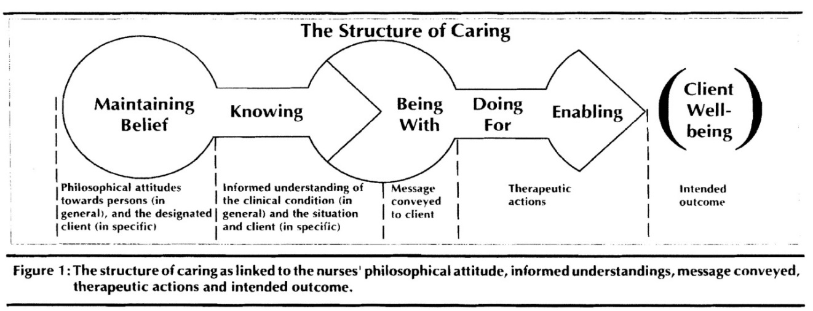

##### cid:D33816C8-B9B2-44E6-B021-7125BC240A68Patient Perspective

CVMC nurses deliver care that is holistic and sensitive to cultural values, experiences, and diversity incorporating each patient’s or person’s perspective.

**Holistic Care** is nursing practice focused on the whole person. It is the unity of the whole person including, but not limited to, mind, body, and spirit (fears, concerns, hopes, and dreams). “The wholeness of a person cannot be separated into individual parts, as the parts are harmonious.”[[10]](#endnote-10)

**Respect** is the state of being valued and regarded with honor and appreciation.

**Dignity** isthe concept that a person has the right to be valued, respected and treated ethically.

**Experiences** are an individual’s life events that may play an important role in the development of the plan of care or action.

**Participation** is the belief that patients should be encouraged and empowered to partner with the healthcare team in care plan development and related therapies, activities, and treatments to facilitate healing, enhance wellbeing and maximize patient control.

**Cultural Care** is based on Dr. Madeleine M. Leininger’s theory of Culture Care Diversity and Universality. Culturally congruent care refers to the use ofculturally based care knowledge and actions used in beneficial and meaningful ways for the client’s health and well-being.

The Cultural Care Diversity and Universality theory is based on several assumptions some of which are summarized here:

1. Nursing is a transcultural care profession and discipline. Human beings develop from birth within specific but diverse cultural values and beliefs. Such values are embedded in the religious, kinship, social, political, cultural, economic, and historical dimensions of their social structure including language. Knowledge of the patient’s cultural care diversities and similarities can guide nurses’ thinking, judgments, and decisions; thus, optimizing outcomes.
2. Therapeutic nursing care can only occur when client cultural care values, expressions, and/or practices are known and used to provide care. A client who experiences nursing care which fails to be reasonably congruent with his/her beliefs and values will show signs of stress, cultural conflict, noncompliance, and ethical moral concerns.
3. Differences between the expectations of the caregiver (nurse) and the care receiver (patient) need to be understood in order to provide beneficial, satisfying and congruent care.

The central purpose of Dr. Leininger’s Theory of Cultural Care Diversity and Universality is to use evidence-based knowledge of cultures and subcultures to support nurses in providing safe, responsible and meaningful care for patients dealing with illness, disabilities, or death.[[11]](#endnote-11)

1. Polit, D. F., Beck, C. T. (2004). Nursing research: Principles and methods. Philadelphia: Lippincott

   Williams & Wilkins. [↑](#endnote-ref-1)
2. Protection of Human Subjects, 45 C.F.R. §46.102 (2009). [↑](#endnote-ref-2)
3. American Nurses Organization. (2004). Scope and standards for nurse administrators, (2nd ed.).

   Washington, D.C.: American Nurses Publishing [↑](#endnote-ref-3)
4. Allina Health Systems. (2005). Charter for professional nursing practice. Retrieved February 7, 2007

   from <http://www.unitedhospital.com/ahs/united.nsf/page/nsg_charter.pdf/$FILE/nsg_charter.pdf> [↑](#endnote-ref-4)
5. Ulrich, B. (2006). Professional development in nursing: Good for everyone. Nephrology Nursing Journal,

   33, 484-530. [↑](#endnote-ref-5)
6. Kramer, M., Maguire, P., Schmalenberg, C. E. (2006). Excellence through evidence: The what, when, and

   where of clinical autonomy. The Journal of Nursing Administration, 36, 479-491. [↑](#endnote-ref-6)
7. Merriam-Webster Dictionary. © 2018 Merriam-Webster Incorporated. Retrieved December 5, 2017 from

   <https://www.merriam-webster.com/dictionary/empathy>. [↑](#endnote-ref-7)
8. American Nurses Association. (2015). Code of Ethics for Nurses with Interpretive Statements.

   Silver Spring, MD: Nursebooks.org [↑](#endnote-ref-8)
9. Swanson, K.M. (1993). Nursing as informed caring for the well-being of others. *Image. 25*(4) 352-357. [↑](#endnote-ref-9)
10. Webster, J., Cowart, P. (1999). An innovative professional nursing practice model. Nursing

    Administration Quarterly, 23, 11-16. [↑](#endnote-ref-10)
11. Reynolds, C. L., Leininger, M. 1993. Madeleine Leininger Cultural Care Diversity and Universality

    Theory. Newbury Park, CA: Sage Publications Inc. [↑](#endnote-ref-11)