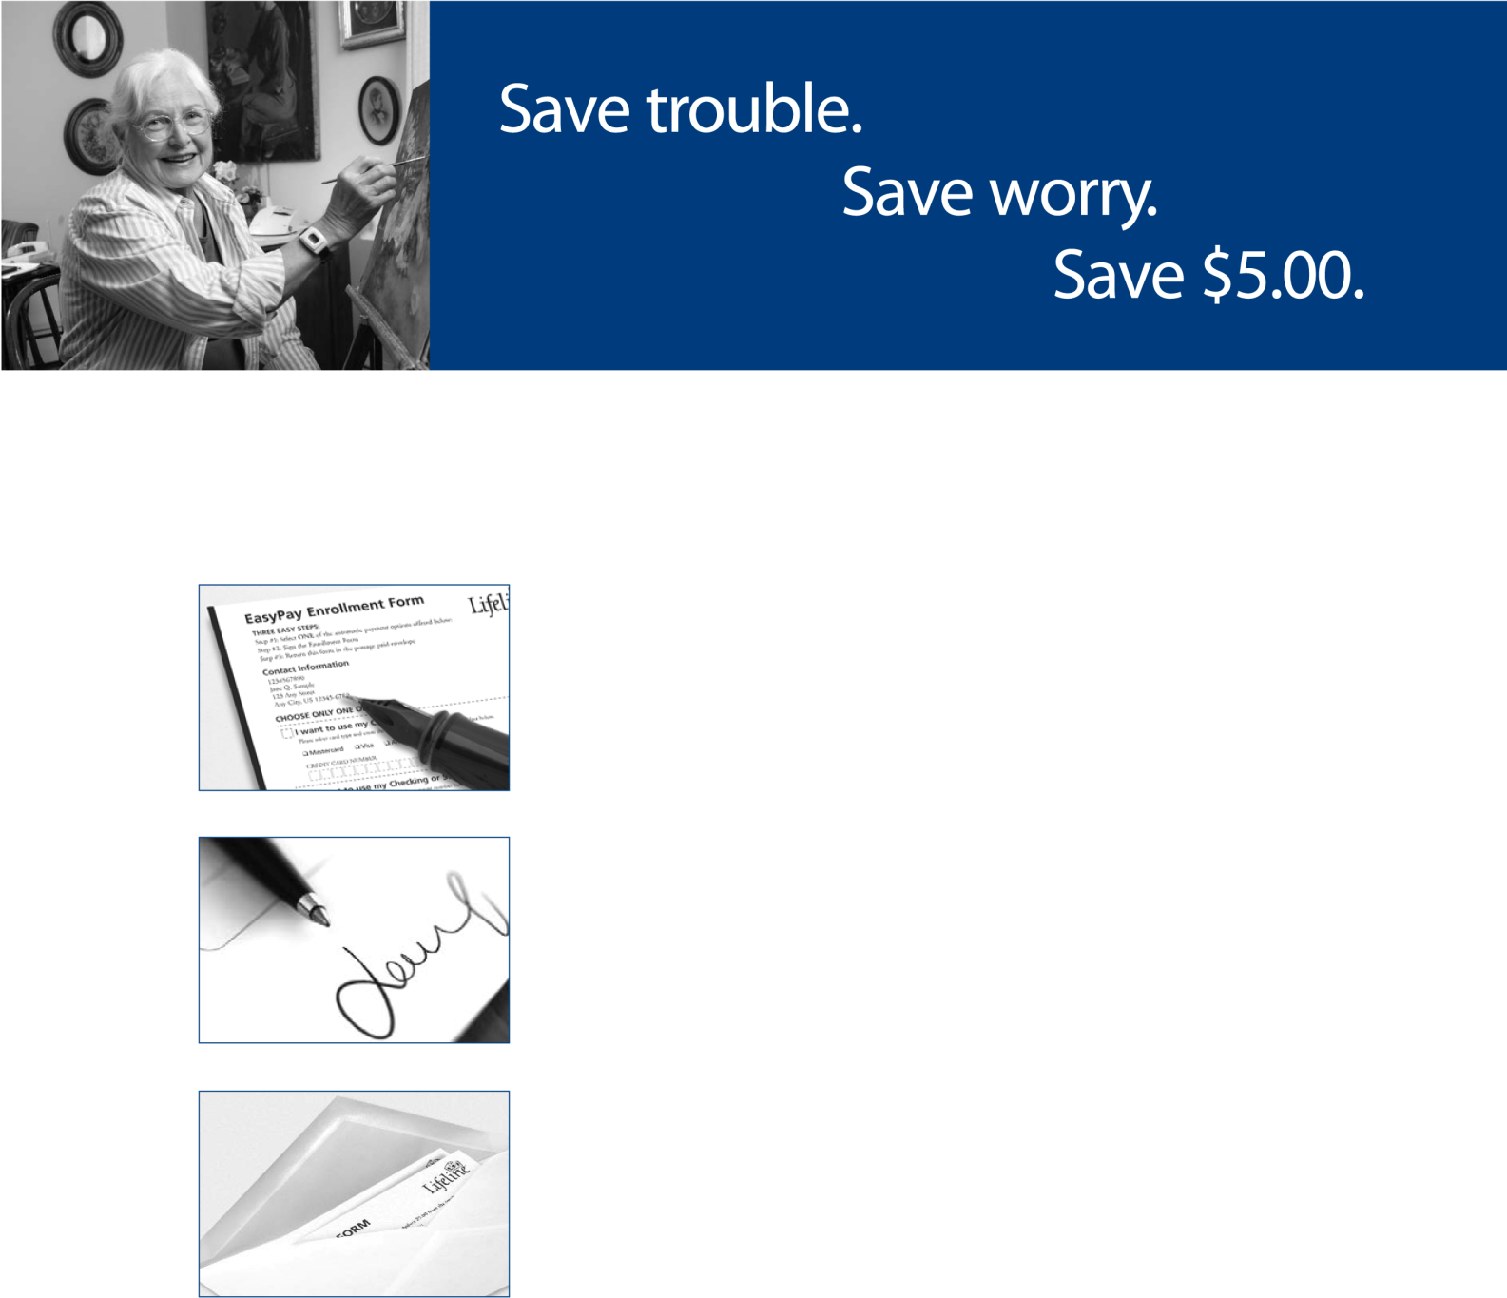

Three Easy Steps to Apply

One

Fill in all the appropriate fields on the enrollment form.

Two

Sign the form.

Three

Place the enrollment form in the enclosed postage-paid envelope.

Many seniors enjoy the convenience of automatic bill pay services for regular monthly expenses like utility bills. Just set up the payment once, and put it out of mind forever.

Now Lifeline is offering the same security and convenience – plus an additional one-time savings of $5.00, for customers who sign up for EasyPay. A $5.00 credit will be applied to your account. You may receive one final paper statement before your initial automated payment.

You’ll have peace of mind knowing that Lifeline’s state-of-the-art technology prevents your personal financial information from being used for anything other than your monthly Lifeline payment.

Sign up for EasyPay today, and relax, knowing that every month your Lifeline bill will be securely paid via credit card or automatic deduction from your bank account. For questions about EasyPay, call 1-800-635-6156.

EasyPay Enrollment Form

THREE EASY STEPS:
Step #1: Select ONE of the automatic payment options offered below
Step #2: Sign the Enrollment Form
CODE: OSTRAN
Step #3: Return this form in the postage-paid envelope

Payer Information
«Payer_1st_Name» «Payer_Last_Name»  «Payer_Address_line_1»  «Payer_Address_line_2»  «Payer_Address_line_3»  «Payer_City», «Payer_State» «Payer_Zipcode» | Payer ID #: «PayerID»  Lifeline Subscriber Name: «Sub_1st_Name» «Sub_Last_Name»  Subscription ID #: «Subscription_ID»

CHOOSE ONLY ONE OPTION
____________________________________________________________________________________________________________________
 I want to use my Credit Card
Please select card type and enter the credit card number and expiration date below.
 MasterCard  Visa  American Express  Discover
CREDIT CARD NUMBER EXPIRATION DATE
  / 
____________________________________________________________________________________________________________________
 I want to use my Checking or Savings Account
Please select account type and enter the account number below.
Auto withdrawal from my:  Checking Account  Savings Account
ROUTING NUMBER ACCOUNT NUMBER
 | 
Please enclose a voided check or bank deposit slip.
____________________________________________________________________________________________________________________
 Please use this account to immediately pay my existing balance. (Note this amount will be immediately charged to your account.)
If you selected auto withdrawal from your bank account, please include a voided check or blank deposit slip.

 | Print name of credit card or bank account holder |  | Account holder signature |  | Date
I hereby authorize Lifeline Systems, Inc., hereinafter called “COMPANY”, to initiate ACH entries (Credit or Debit), and to initiate if necessary, adjustments for any entries in error to my bank account indicated below and the depository bank named below, hereinafter called “DEPOSITORY”, to credit and/or debit the same to my account.
This authority is to remain in full force and effective until COMPANY has received written notification from me of its termination in such time and manner as to afford COMPANY and DEPOSITORY a reasonable opportunity to act upon it. The personal financial information contained in this enrollment form is considered private and confidential, and is intended solely for use by Lifeline in ensuring payment for your Personal Emergency Response Services.

